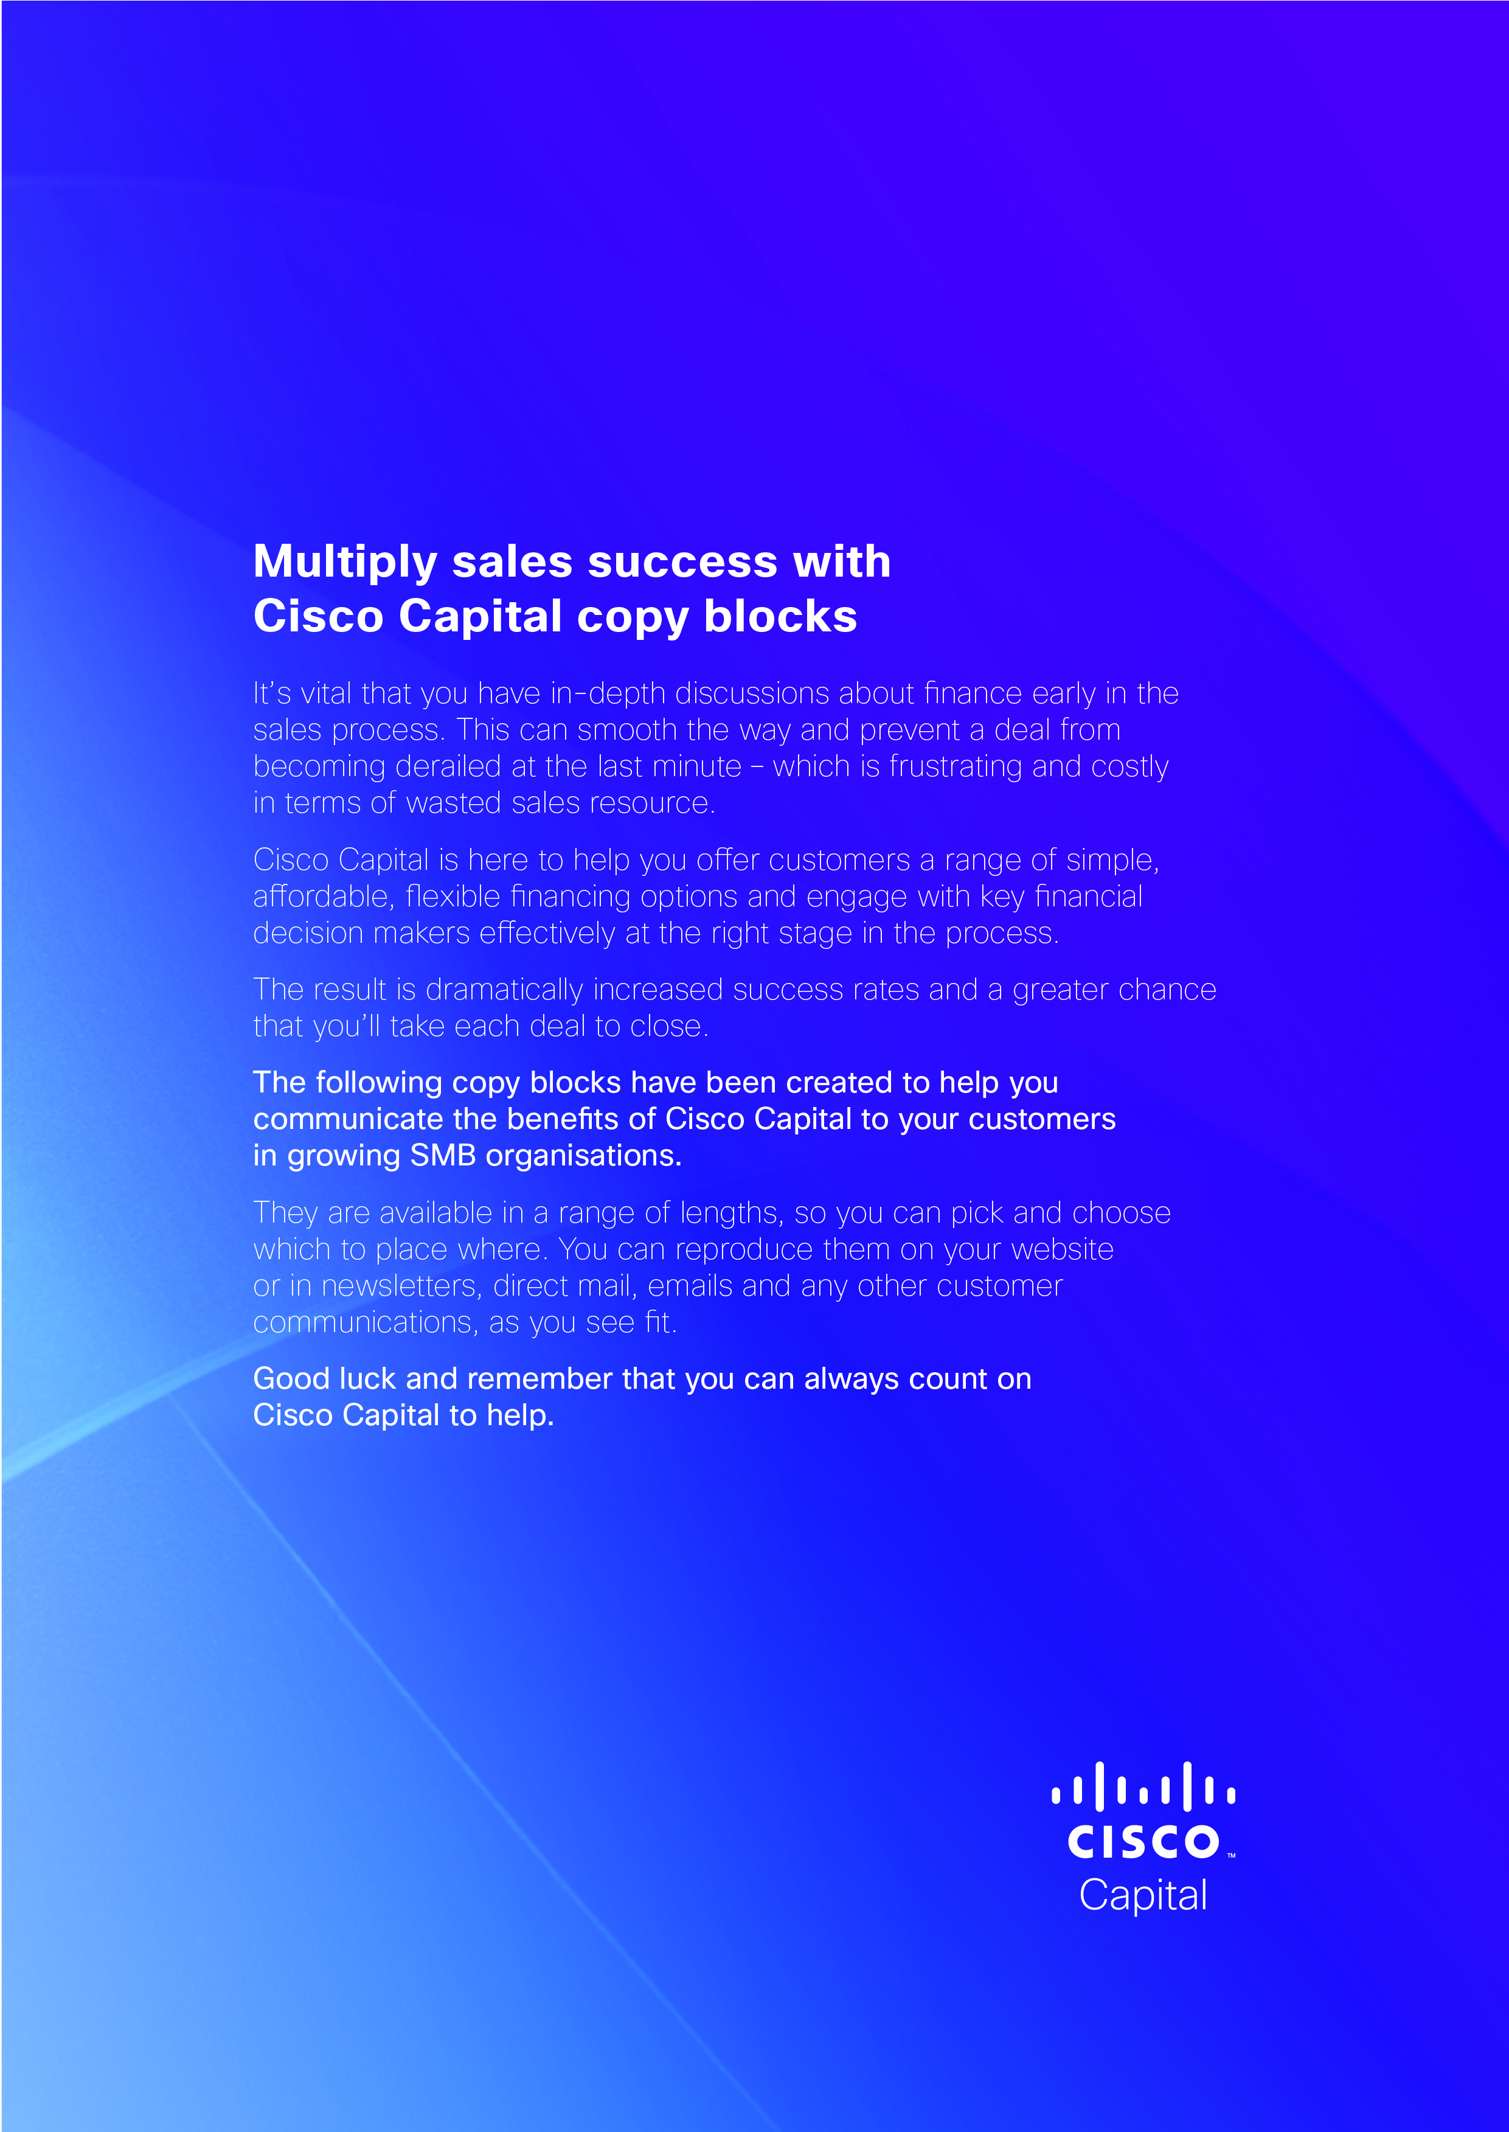

249-word copy block

Count on Cisco Capital for financing technology

Looking for a smarter, more flexible way to ensure your business has the latest technology that improves productivity and raises your competitiveness? Then Cisco Capital can help.

When it comes to financing technology with Cisco Capital you can rely on five great benefits.

1. Budget management is easier – as you can link payment options to a predictable monthly cost to ease cash flow
2. Your cash is protected – with capital free to be spent on the other business priorities, leaving open lines of credit, such as bank loans
3. Available funds are used wisely – with a variety of on-and-off balance sheet funding options to suit your business
4. IT projects finish sooner – so you get to enjoy more of the benefits, like reduced costs and increased efficiency, straight away
5. Up-to-date technology – so you can gain from the latest technological innovations by refreshing your equipment, within the terms of an existing agreement, without a large cash investment

Cisco Capital financing is relied on by many small and mid-sized businesses to make the financing process simple and affordable.

As a wholly-owned subsidiary of Cisco Systems Inc, Cisco Capital can relate their financial advice to align your IT and business strategy. They can provide the complete solution with the financing agreement structured to include software, installation and maintenance, as well as equipment.

To find out how you can Count on Cisco Capital for technology financing, visit: [www.ciscocapital.com/emea](http://www.ciscocapital.com/emea)



98-word copy block

Count on Cisco Capital for financing technology

Looking for a smarter way to provide your business with the latest technology to improve productivity and raise competitiveness? Cisco Capital financing has five great benefits.

1. Easier budget management – through variety of payment options
2. Cash preservation – freeing up capital for other business priorities
3. Best use of available funds – with on-and-off balance sheet funding
4. IT projects finish sooner – delivering more benefits, earlier
5. Up-to-date technology – by refreshing your equipment, without a large cash investment

To find out how you can Count on Cisco Capital for technology financing: [www.ciscocapital.com/emea](http://www.ciscocapital.com/emea)

48-word copy block

Count on Cisco Capital for financing technology

Looking for a smarter way to provide your business with the latest technology to improve productivity and raise competitiveness? Cisco Capital financing, delivers more benefits sooner, eases cash flow and frees up your capital. Count on Cisco Capital for technology financing: [www.ciscocapital.com/emea](http://www.ciscocapital.com/emea)

