Date: November 5, 2012
Name of Product: Cisco Small Business Unmanaged Ethernet Switches
Contact for more Information: accessibility@cisco.com

Summary Table - Voluntary Product Accessibility Template
Criteria | Supporting Features | Remarks and Explanations
Section 1194.21 Software Applications and Operating Systems | Not Applicable | Units are self-contained and have no management or user software interface.
Section 1194.22 Web-based internet information and applications | Not Applicable | Units are self-contained and have no management or user software interface.
Section 1194.23 Telecommunications Products | Not Applicable | Units are self-contained and have no management or user software interface.
Section 1194.24 Video and Multi-media Products | Not Applicable
Section 1194.25 Self-Contained, Closed Products | Included | Includes the physical hardware
Section 1194.26 Desktop and Portable Computers | Not Applicable
Section 1194.31 Functional Performance Criteria | Not Applicable | Units are self-contained and have no management or user software interface.
Section 1194.41 Information, Documentation and Support - Detail | Included

The following hardware appliances are considered exempt from Section 508 because of the 1194.3(f) Back Office Exemption Clause. Products located in spaces frequented only by service personnel for maintenance, repair, or occasional monitoring of equipment are not required being compliant with Section 508. The follow physical hardware product is considered back office equipment.
All Cisco SF100 series unmanaged switches. Please see http://www.cisco.com/en/US/products/ps10863/prod_models_comparison.html for the latest model numbers covered by this VPAT.

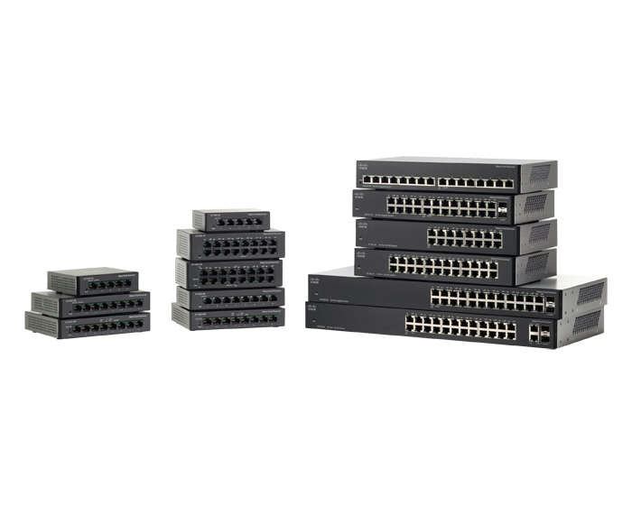
Figure 1

Figure 1 shows a representation of the SF100 series unmanaged switches.

Section 1194.25: Self-Contained, Closed Products – Detail

Cisco Small Business SF100 Series Switches (Physical Hardware)
508 Clause | Criteria | Supporting Features | Remarks and Explanations
1194.25(a) | Self contained products shall be usable by people with disabilities without requiring an end-user to attach Assistive Technology to the product. Personal headsets for private listening are not Assistive Technology. | Not Applicable
1194.25(b) | When a timed response is required, the user shall be alerted and given sufficient time to indicate more time is required. | Not Applicable
1194.25(c) | Where a product utilizes touchscreens or contact-sensitive controls, an input method shall be provided that complies with §1194.23 (k) (1) through (4). | Not Applicable
1194.25(d) | When biometric forms of user identification or control are used, an alternative form of identification or activation, which does not require the user to possess particular biological characteristics, shall also be provided. | Not Applicable
1194.25(e) | When products provide auditory output, the audio signal shall be provided at a standard signal level through an industry standard connector that will allow for private listening. The product must provide the ability to interrupt, pause, and restart the audio at anytime. | Not Applicable
1194.25(f) | When products deliver voice output in a public area, incremental volume control shall be provided with output amplification up to a level of at least 65 dB. Where the ambient noise level of the environment is above 45 dB, a volume gain of at least 20 dB above the ambient level shall be user selectable. A function shall be provided to automatically reset the volume to the default level after every use. | Not Applicable
1194.25(g) | Color coding shall not be used as the only means of conveying information, indicating an action, prompting a response, or distinguishing a visual element. | Not Applicable
1194.25(h) | When a product permits a user to adjust color and contrast settings, a range of color selections capable of producing a variety of contrast levels shall be provided. | Not Applicable
1194.25(i) | Products shall be designed to avoid causing the screen to flicker with a frequency greater than 2 Hz and lower than 55 Hz. | Not Applicable
1194.25(j1) | Products which are freestanding, non-portable, and intended to be used in one location and which have operable controls shall comply with the following: The position of any operable control shall be determined with respect to a vertical plane, which is 48 inches in length, centered on the operable control, and at the maximum protrusion of the product within the 48 inch length on products which are freestanding, non-portable, and intended to be used in one location and which have operable controls. | Not Applicable
1194.25(j2) | Products which are freestanding, non-portable, and intended to be used in one location and which have operable controls shall comply with the following: Where any operable control is 10 inches or less behind the reference plane, the height shall be 54 inches maximum and 15 inches minimum above the floor. | Not Applicable
1194.25(j3) | Products which are freestanding, non-portable, and intended to be used in one location and which have operable controls shall comply with the following: Where any operable control is more than 10 inches and not more than 24 inches behind the reference plane, the height shall be 46 inches maximum and 15 inches minimum above the floor. | Not Applicable
1194.25(j4) | Products which are freestanding, non-portable, and intended to be used in one location and which have operable controls shall comply with the following: Operable controls shall not be more than 24 inches behind the reference plane. | Not Applicable

Section 1194.41: Information, Documentation and Support
508 Clause | Criteria | Supporting Features | Remarks and Explanations
1194.41(a) | Product support documentation provided to end-users shall be made available in alternate formats upon request, at no additional charge | Supports | Accessible documentation is available through Cisco Technical Assistance Center (TAC) upon request.
1194.41(b) | End-users shall have access to a description of the accessibility and compatibility features of products in alternate formats or alternate methods upon request, at no additional charge. | Supports | Accessible documentation is available through Cisco Technical Assistance Center (TAC) upon request.
1194.41(c) | Support services for products shall accommodate the communication needs of end-users with disabilities. | Supports | Cisco conforms through equal facilitation. Customers may reach Cisco Technical Assistance Center (TAC) via Phone, Email or Web Form. All cases open through email or web are opened as Priority 3 cases. All Priority 1 or Priority 2 case can only be opened via the telephone. TTY users must call the Text Relay Service (TRS) by dialing 711 or their state Video Relay Service (VRS) and have the TRS agent contact Cisco TAC via voice.)

