Date: March 25, 2015
Name of Product: Cisco TelePresence MX700 & MX800 & Cisco TelePresence Touch 10 interface

Contact for more Information: accessibility@cisco.com

Summary Table - Voluntary Product Accessibility Template
Criteria | Supporting Features | Remarks and Explanations
Section 1194.21 Software Applications and Operating Systems | Included | Software interface on Display and TelePresence Touch
Section 1194.22 Web-based internet information and applications | Not Applicable | See VPAT for Cisco Unified Communications Manager (requires Cisco Unified Communications Manager Version 8.6 or later)
Section 1194.23 Telecommunications Products | Included | MX 700, MX 800, and TelePresence Touch
Section 1194.24 Video and Multi-media Products | Included | MX700 and MX800
Section 1194.25 Self-Contained, Closed Products | Not Applicable
Section 1194.26 Desktop and Portable Computers | Not Applicable
Section 1194.31 Functional Performance Criteria | Included
Section 1194.41 Information, Documentation and Support - Detail | Included

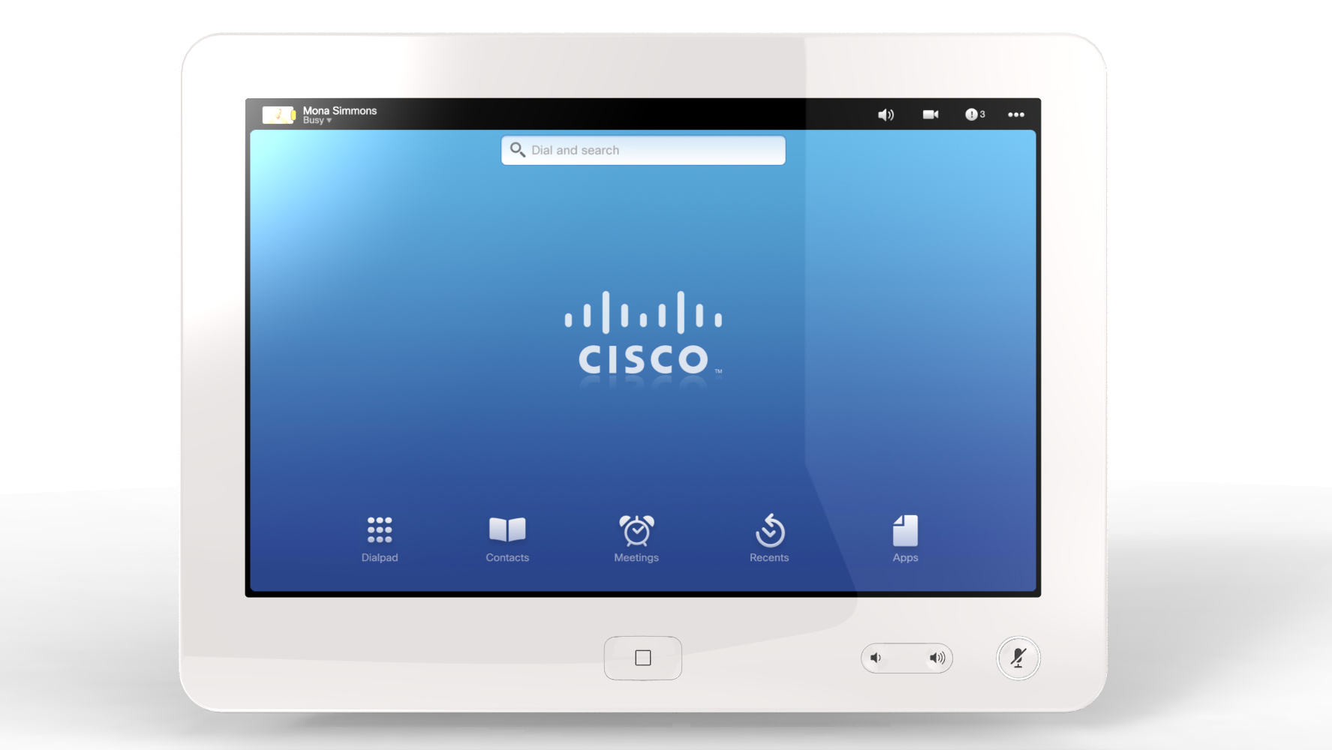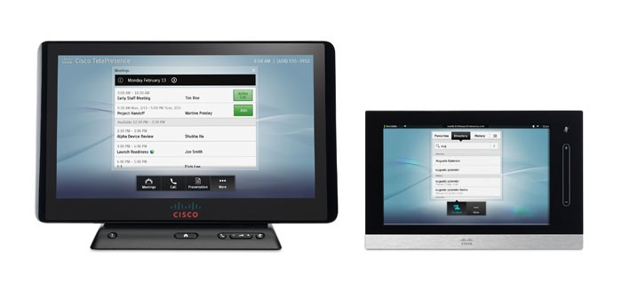

Figure 1: Cisco TelePresence Touch 10 inch Devices
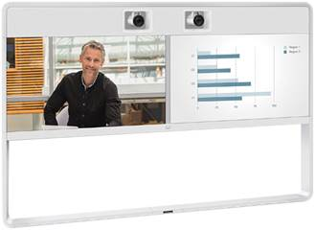

Figure 2: MX700 Dual 55” screen (Dual Camera Shown is Available as an Option for Both the MX700 and MX800 Single, and as the only option for MX800 Dual)
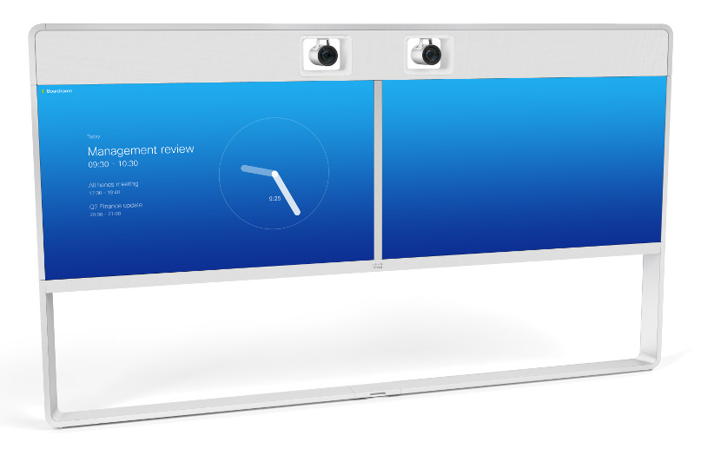
Figure 3: MX800 Single and Dual 70” Screen.

Section 1194.21: Software Applications and Operating Systems – Detail

Cisco TelePresence MX-700, MX-800 and TelePresence Touch 10-inch
508 Clause | Criteria | Supporting Features | Remarks and Explanations
1194.21(a) | When software is designed to run on a system that has a keyboard, product functions shall be executable from a keyboard where the function itself or the result of performing a function can be discerned textually. | Does Not Support | TelePresence Touch is a capacitive touch display.
1194.21(b) | Applications shall not disrupt or disable activated features of other products that are identified as accessibility features, where those features are developed and documented according to industry standards. Applications also shall not disrupt or disable activated features of any operating system that are identified as accessibility features where the application programming interface for those accessibility features has been documented by the manufacturer of the operating system and is available to the product developer. | Not Applicable | Product OS does not have embedded Accessibility Features
1194.21(c) | A well-defined on-screen indication of the current focus shall be provided that moves among interactive interface elements as the input focus changes. The focus shall be programmatically exposed so that Assistive Technology can track focus and focus changes. | Supports
1194.21(d) | Sufficient information about a user interface element including the identity, operation and state of the element shall be available to Assistive Technology. When an image represents a program element, the information conveyed by the image must also be available in text. | Does Not Support
1194.21(e) | When bitmap images are used to identify controls, status indicators, or other programmatic elements, the meaning assigned to those images shall be consistent throughout an application's performance. | Not Applicable
1194.21(f) | Textual information shall be provided through operating system functions for displaying text. The minimum information that shall be made available is text content, text input caret location, and text attributes. | Supports
1194.21(g) | Applications shall not override user selected contrast and color selections and other individual display attributes. | Does Not Support | Product does not have contrast or color selections. Product does have Display Settings to adjust Brightness and Color Selections of Display (Cold, Neutral, Warm, and Custom)
1194.21(h) | When animation is displayed, the information shall be displayable in at least one non-animated presentation mode at the option of the user. | Not Applicable | No animations
1194.21(i) | Color coding shall not be used as the only means of conveying information, indicating an action, prompting a response, or distinguishing a visual element. | Supports
1194.21(j) | When a product permits a user to adjust color and contrast settings, a variety of color selections capable of producing a range of contrast levels shall be provided. | Supports | Product does have Display Settings to adjust Brightness and Color Selections of Display (Cold, Neutral, Warm, and Custom)
1194.21(k) | Software shall not use flashing or blinking text, objects, or other elements having a flash or blink frequency greater than 2 Hz and lower than 55 Hz. | Not Applicable | No instances of blinking or flashing.
1194.21(l) | When electronic forms are used, the form shall allow people using Assistive Technology to access the information, field elements, and functionality required for completion and submission of the form, including all directions and cues. | Does Not Support | There are form elements within the TelePresence Touch display, but the overall Software OS does not have Assistive Technology functionality.

Section 1194.23 Telecommunications Products

Cisco Telepresence System MX700 and MX800
Clause | Criteria | Status | Comments
1194.23(a) | Telecommunications products or systems which provide a function allowing voice communication and which do not themselves provide a TTY functionality shall provide a standard non-acoustic connection point for TTYs. Microphones shall be capable of being turned on and off to allow the user to intermix speech with TTY use. | Does Not Support | Product does not provide TTY functionality.
1194.23(b) | Telecommunications products which include voice communication functionality shall support all commonly used cross-manufacturer non-proprietary standard TTY signal protocols. | Does Not Support | Product does not provide TTY functionality.
1194.23(c) | Voice mail, auto-attendant, and interactive voice response telecommunications systems shall be usable by TTY users with their TTYs. | Not Applicable | This requirement applies only to voice mail, auto-attendant, and interactive voice response systems.
1194.23(d) | Voice mail, messaging, auto-attendant, and interactive voice response telecommunications systems that require a response from a user within a time interval, shall give an alert when the time interval is about to run out, and shall provide sufficient time for the user to indicate more time is required. | Not Applicable | This requirement applies only to voice mail, auto-attendant, and interactive voice response systems.
1194.23(e) | Where provided, caller identification and similar telecommunications functions shall also be available for users of TTYs, and for users who cannot see displays. | Does Not Support | No support for TTY users.  Call ID is not provided fro users who cannot see displays.
1194.23(f) | For transmitted voice signals, telecommunications products shall provide a gain adjustable up to a minimum of 20 dB. For incremental volume control, at least one intermediate step of 12 dB of gain shall be provided. | Supports | It is recommended to use Assistive Listening devices to enhance the voice signals for individuals with hearing impairments. Refer the recommendation section in this document.
1194.23(g) | If the telecommunications product allows a user to adjust the receive volume, a function shall be provided to automatically reset the volume to the default level after every use. | Does Not Support | Volume is not reset to a default level after every use. However, the output volume does not exceed 20db of gain.
1194.23(h) | Where a telecommunications product delivers output by an audio transducer which is normally held up to the ear, a means for effective magnetic wireless coupling to hearing technologies shall be provided. | Not Applicable | Product does not have a handset.
1194.23(i) | Interference to hearing technologies (including hearing aids, cochlear implants, and assistive listening devices) shall be reduced to the lowest possible level that allows a user of hearing technologies to utilize the telecommunications product. | Supports | The Assistive Listening devices could be used in the TelePresence meeting rooms. Refer the recommendation section in this document.
1194.23(j) | Products that transmit or conduct information or communication, shall pass through cross-manufacturer, non-proprietary, industry-standard codes, translation protocols, formats or other information necessary to provide the information or communication in a usable format. Technologies which use encoding, signal compression, format transformation, or similar techniques shall not remove information needed for access or shall restore it upon delivery. | Supports
1194.23(k1) | Products which have mechanically operated controls or keys shall comply with the following: Controls and Keys shall be tactilely discernible without activating the controls or keys. | Does Not Support | Product relies on a touch panel display (Cisco TelePresence Touch) that does not have tactile discernable buttons (Mute and Volume keys)
1194.23(k2) | Products which have mechanically operated controls or keys shall comply with the following: Controls and Keys shall be operable with one hand and shall not require tight grasping, pinching, twisting of the wrist. The force required to activate controls and keys shall be 5 lbs. (22.2N) maximum. | Supports with Exceptions | The TelePresence Touch Mute and Volume keys meet the force requirement. However, the Touch is a capacitive device, which requires the touch of finger to use the product.  The HD camera does has remote capabilities to pan, tilt and zoom through the interface on the TelePresence Touch.
1194.23(k3) | Products which have mechanically operated controls or keys shall comply with the following: If key repeat is supported, the delay before repeat shall be adjustable to at least 2 seconds. Key repeat rate shall be adjustable to 2 seconds per character. | Supports | No basic call feature buttons on the phone have an auto repeat function.
1194.23(k4) | Products which have mechanically operated controls or keys shall comply with the following: The status of all locking or toggle controls or keys shall be visually discernible, and discernible either through touch or sound. | Supports | The TelePresence Touch Mute keys and the Hold feature provide visual indicators. However, for these 2 features there is not a complimentary audio indicator.

1194.23(k4) | Products which have mechanically operated controls or keys shall comply with the following: The status of all locking or toggle controls or keys shall be visually discernible, and discernible either through touch or sound.

Section 1194.24: Video and Multi-media Products – Detail
508 Clause | Criteria | Supporting Features | Remarks and Explanations
1194.24(a) | All analog television displays 13 inches and larger, and computer equipment that includes analog television receiver or display circuitry, shall be equipped with caption decoder circuitry which appropriately receives, decodes, and displays closed captions from broadcast, cable, videotape, and DVD signals. As soon as practicable, but not later than July 1, 2002, widescreen digital television (DTV) displays measuring at least 7.8 inches vertically, DTV sets with conventional displays measuring at least 13 inches vertically, and stand-alone DTV tuners, whether or not they are marketed with display screens, and computer equipment that includes DTV receiver or display circuitry, shall be equipped with caption decoder circuitry which appropriately receives, decodes, and displays closed captions from broadcast, cable, videotape, and DVD signals. | Not Applicable
1194.24(b) | Television tuners, including tuner cards for use in computers, shall be equipped with secondary audio program playback circuitry. | Not Applicable
1194.24(c) | All training and informational video and multimedia productions which support the agency's mission, regardless of format, that contain speech or other audio information necessary for the comprehension of the content, shall be open or closed captioned. | Does Not Support
1194.24(d) | All training and informational video and multimedia productions which support the agency's mission, regardless of format, that contain visual information necessary for the comprehension of the content, shall be audio described. | Not Applicable
1194.24(e) | Display or presentation of alternate text presentation or audio descriptions shall be user-selectable unless permanent. | Does Not Support

Section 1194.31: Functional Performance Criteria – Detail
Clause | Criteria | Status | Comments
1194.31(a) | At least one mode of operation and information retrieval that does not require user vision shall be provided, or support for Assistive Technology used by people who are blind or visually impaired shall be provided. | Does Not Support
1194.31(b) | At least one mode of operation and information retrieval that does not require visual acuity greater than 20/70 shall be provided in audio and enlarged print output working together or independently, or support for Assistive Technology used by people who are visually impaired shall be provided. | Support with Exceptions | The interface on the TelePresence Touch does not have low vision features to increase the text size or change the color schemes to meet low vision requirements.  At normal working distances, visual acuity greater than 20/70 is not required. Paragraph 707.5.6.2 in the ADA accessibility design guidelines (published in the Federal Register, November 16, 1999) states that, Characters displayed on a screen shall be in a sans serif font. Characters shall be 3/16 inch (4.8 mm) minimum in height based on the uppercase letter I. Characters shall contrast with their background with either light characters on a dark background or dark characters on a light background.
1194.31(c) | At least one mode of operation and information retrieval that does not require user hearing shall be provided, or support for Assistive Technology used by people who are deaf or hard of hearing shall be provided | Supports
1194.31(d) | Where audio information is important for the use of a product, at least one mode of operation and information retrieval shall be provided in an enhanced auditory fashion, or support for assistive hearing devices shall be provided. | Supports
1194.31(e) | At least one mode of operation and information retrieval that does not require user speech shall be provided, or support for Assistive Technology used by people with disabilities shall be provided. | Supports | Recommended Assistive Listening Devices, Captioning Solutions, and Transcription Services are needed to meet this requirement.
1194.31(f) | At least one mode of operation and information retrieval that does not require fine motor control or simultaneous actions and that is operable with limited reach and strength shall be provided. | Does Not Support | The TelePresence Touch is a capacitive touch device that relies on touch to use the interface. A capacitive stylus could be used by users with a mobility impairment.

Section 1194.41: Information, Documentation and Support
508 Clause | Criteria | Supporting Features | Remarks and Explanations
1194.41(a) | Product support documentation provided to end-users shall be made available in alternate formats upon request, at no additional charge | Supports | Accessible documentation is available through Cisco TAC upon request.
1194.41(b) | End-users shall have access to a description of the accessibility and compatibility features of products in alternate formats or alternate methods upon request, at no additional charge. | Supports | Accessible documentation is available through Cisco TAC upon request.
1194.41(c) | Support services for products shall accommodate the communication needs of end-users with disabilities. | Supports | Cisco conforms through equal facilitation. Customers may reach Cisco Technical Assistance Center (TAC) via Phone, Email or Web Form. All cases open through email or web are opened as Priority 3 cases. All Priority 1 or Priority 2 case can only be opened via the telephone. TTY users must call the Text Relay Service (TRS) by dialing 711 and have the TRS agent contact Cisco TAC via voice.

