Date: October 15, 2014
Name of Product: Cisco Desktop Collaboration Experience DX650, DX70 and DX80, 10.2.2
Contact for more Information: accessibility@cisco.com

Summary Table: Voluntary Product Accessibility Template
Criteria | Supporting Features | Remarks and Explanations
Section 1194.21 Software Applications and Operating Systems | Included | DX650 Phone Application (Android), Settings, and overall Interface
Section 1194.22 Web-based internet information and applications | Not Applicable
Section 1194.23 Telecommunications Products | Included
Section 1194.24 Video and Multi-media Products | Included
Section 1194.25 Self-Contained, Closed Products | Not Applicable
Section 1194.26 Desktop and Portable Computers | Not Applicable
Section 1194.31 Functional Performance Criteria | Included
Section 1194.41 Information, Documentation and Support - Detail | Included

DX650 | DX70 | DX80
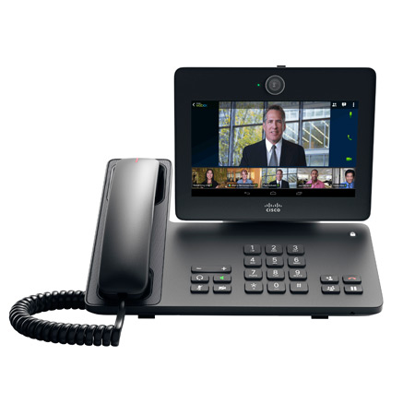 | 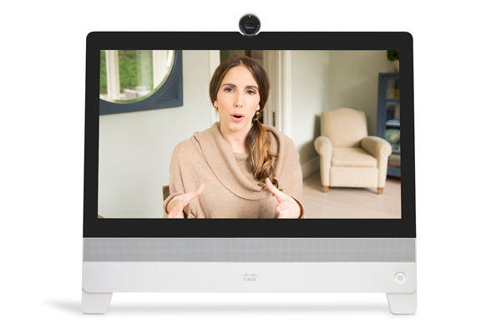 | 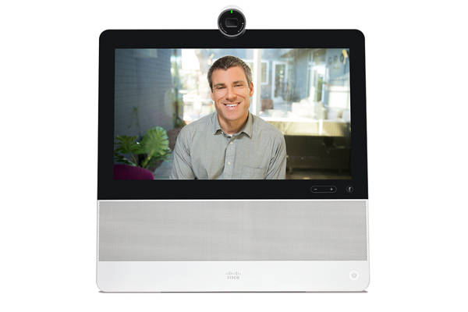
7-inch, 16:9 screen for an engaging experience for video calls and processing needs | 14-inch, 16:9 screen for an engaging experience for video calls and processing needs | 23-inch, 16:9 screen for an engaging experience during video calls and processing needs

Date Sheets:
DX650: http://www.cisco.com/en/US/products/ps12959/index.html

DX70: http://www.cisco.com/c/en/us/products/collaboration-endpoints/dx70/index.html

DX80: http://www.cisco.com/c/en/us/products/collaboration-endpoints/dx80/index.html

Section 1194.21: Software Applications and Operating Systems – Detail

DX650 Phone Android Application
508 Clause | Criteria | Supporting Features | Remarks and Explanations
1194.21(a) | When software is designed to run on a system that has a keyboard, product functions shall be executable from a keyboard where the function itself or the result of performing a function can be discerned textually. | Supports | The primary input for the DX Series is controlled through a capacitive touch display. The DX series can be used with a Bluetooth or USB keyboard.  Android 4.1.1 Explore by Touch features are supported through the DX Series Operating System and Phone Application.  However, the keyboard support is recommended for text entry only and for the navigation of the GUI elements in the interface.
1194.21(b) | Applications shall not disrupt or disable activated features of other products that are identified as accessibility features, where those features are developed and documented according to industry standards. Applications also shall not disrupt or disable activated features of any operating system that are identified as accessibility features where the application programming interface for those accessibility features has been documented by the manufacturer of the operating system and is available to the product developer. | Supports with Exceptions | The following Android OS (ICS) accessibility features were tested: Talkback, Explore by Touch, and Font Size. The DX650 does not have inverted or contrast setting.  The DX Series GUI elements do not inherit Text Size changes.
1194.21(c) | A well-defined on-screen indication of the current focus shall be provided that moves among interactive interface elements as the input focus changes. The focus shall be programmatically exposed so that Assistive Technology can track focus and focus changes. | Supports
1194.21(d) | Sufficient information about a user interface element including the identity, operation and state of the element shall be available to Assistive Technology. When an image represents a program element, the information conveyed by the image must also be available in text. | Supports with Exceptions | Some elements do not have text equivalent labels that are spoken by Talkback.
1194.21(e) | When bitmap images are used to identify controls, status indicators, or other programmatic elements, the meaning assigned to those images shall be consistent throughout an application's performance. | Supports
1194.21(f) | Textual information shall be provided through operating system functions for displaying text. The minimum information that shall be made available is text content, text input caret location, and text attributes. | Supports
1194.21(g) | Applications shall not override user selected contrast and color selections and other individual display attributes. | Does Not Support | The DX Series GUI elements do not inherit Text Size changes and does not provide a low contrast theme.
1194.21(h) | When animation is displayed, the information shall be displayable in at least one non-animated presentation mode at the option of the user. | Not Applicable | No instances animations in product.
1194.21(i) | Color coding shall not be used as the only means of conveying information, indicating an action, prompting a response, or distinguishing a visual element. | Supports | No instances of conveying information solely through color.
1194.21(j) | When a product permits a user to adjust color and contrast settings, a variety of color selections capable of producing a range of contrast levels shall be provided. | Not Applicable | There is not a feature built into this product to adjust the color and contrast.
1194.21(k) | Software shall not use flashing or blinking text, objects, or other elements having a flash or blink frequency greater than 2 Hz and lower than 55 Hz. | Supports | No instances of flashing or blinking objects within the danger range of 2 Hz and 55 Hz.
1194.21(l) | When electronic forms are used, the form shall allow people using Assistive Technology to access the information, field elements, and functionality required for completion and submission of the form, including all directions and cues. | Supports with Exceptions | Some elements do not have text equivalent labels that are spoken by Talkback.

Section 1194.23 Telecommunications Products
Clause | Criteria | Status | Comments
1194.23(a) | Telecommunications products or systems which provide a function allowing voice communication and which do not themselves provide a TTY functionality shall provide a standard non-acoustic connection point for TTYs. Microphones shall be capable of being turned on and off to allow the user to intermix speech with TTY use. | Supports through Equivalent Facilitation | Most TTY's that permit an electronic, non-acoustic connection to the telephone network do so through an RJ-11 analog telephone line. . The Cisco ATA-186 FXS port may be used as an adjunct to the IP phone, to provide the RJ-11 analog line; any other Cisco voice gateway with FXS port may also be used.
1194.23(b) | Telecommunications products which include voice communication functionality shall support all commonly used cross-manufacturer non-proprietary standard TTY signal protocols. | Supports | The Baudot tones used by U.S. standard TTY's are transmitted and received reliably G.711 is the recommended codec for TTY devices.
1194.23(c) | Voice mail, auto-attendant, and interactive voice response telecommunications systems shall be usable by TTY users with their TTYs. | Not Applicable | This requirement applies only to voice mail, auto-attendant, and interactive voice response systems.
1194.23(d) | Voice mail, messaging, auto-attendant, and interactive voice response telecommunications systems that require a response from a user within a time interval, shall give an alert when the time interval is about to run out, and shall provide sufficient time for the user to indicate more time is required. | Not Applicable | This requirement applies only to voice mail, auto-attendant, and interactive voice response systems.
1194.23(e) | Where provided, caller identification and similar telecommunications functions shall also be available for users of TTYs, and for users who cannot see displays. | Supports when combined with compatible Assistive Technology | If TTY's are used with IP Phones in the manner outlined in the section that addresses paragraph 1194.23(a), Caller ID and similar functions will continue to appear appropriately on the terminal's display.  For users who cannot see displays, provision of Caller ID information requires the use of the Tenacity accessaphone (AAP), a Windows software monitors and controls the Phone application on the DX650. AAP provides the DX650 end user with complete management of telephone calls through the use of customizable keyboard controls and an audible messaging system (audible caller ID and Message Waiting Indicator - MWI). Additional information can be accessed through the following URL: http://www.accessaphone.com/.  Cisco Unified Communication Manager (CUCM) provides an Audio Message Waiting Indicator. The IP Phones support an accessibility feature for visually impaired who cannot see Message Waiting Indicator light (or for who have a phone that does not support a MW light) by providing an audible message waiting tone, known otherwise as stutter dial tone, placed at the beginning of the dial tone when the user goes off-hook.  The DX Series endpoints are an Android Devices, Android 4.1.1. The Accessibility of the Phone application is detailed in 1194.21 of this VPAT. The Accessibility of other Cisco applications pre-installed on the DX Series, e.g. Jabber IM and WebEx, have independent VPATs.
1194.23(f) | For transmitted voice signals, telecommunications products shall provide a gain adjustable up to a minimum of 20 dB. For incremental volume control, at least one intermediate step of 12 dB of gain shall be provided. | Supports when combined with compatible Assistive Technology | The DX Series endpoints meet the FCC 68 requirements for volume gain of minimum of 12dB of gain from default factor setting. To achieve 20dB or greater, Cisco recommends using an inline amplifier, such as Plantronic EC-225. The Plantronics Clarity EC225/ECE225* inline amplifier is an example of a manufacturer selling 3rd party handset and headset amplifiers. Recommended amplifiers can be viewed through the following URL: http://www.plantronics.com/media/media_resources/literature/user_guides/cisco_setup.pdf
1194.23(g) | If the telecommunications product allows a user to adjust the receive volume, a function shall be provided to automatically reset the volume to the default level after every use. | Supports with Exceptions | The DX6 Series endpoings provide an adjustable base receive volume, and the call volume is also adjustable on a per call basis.  The maximum gain of 15db meets the FCC safety standard in 68.317, and the user's volume preference is retained for improved usability.
1194.23(h) | Where a telecommunications product delivers output by an audio transducer which is normally held up to the ear, a means for effective magnetic wireless coupling to hearing technologies shall be provided. | Supports | The DX650 handsets has primary inductive coils, which allow the phones to be used with inductively coupled assistive hearing devices, such as hearing aids and cochlear implants. Cisco phones meets FCC Part 68 requirements for Hearing Aid Compatibility (HAC).  The DX70 and DX80 do not have handsets.
1194.23(i) | Interference to hearing technologies (including hearing aids, cochlear implants, and assistive listening devices) shall be reduced to the lowest possible level that allows a user of hearing technologies to utilize the telecommunications product. | Supports | The DX650 meets the FCC standards for electro-magnetic shielding.  The DX70 and DX80 do not have handsets.
1194.23(j) | Products that transmit or conduct information or communication, shall pass through cross-manufacturer, non-proprietary, industry-standard codes, translation protocols, formats or other information necessary to provide the information or communication in a usable format. Technologies which use encoding, signal compression, format transformation, or similar techniques shall not remove information needed for access or shall restore it upon delivery. | Supports | The Baudot tones used by U.S. standard TTY's are transmitted and received reliably by the IP Phones.
1194.23(k1) | Products which have mechanically operated controls or keys shall comply with the following: Controls and Keys shall be tactilely discernible without activating the controls or keys. | Supports with Excpetions | The dial pads on the DX650 is arranged in a standard layout, with a raised nib on the 5-key, thereby making “tactile navigation” easier for visually impaired users. In addition, Cisco supports a 3rd party software from Tenacity that allow user to control the Cisco Unified IP Phone from a standard Windows based PC and keyboard.  On the feature-rich telephones, tactile navigation of the special function keys is facilitated by the use of a consistent key layout that includes at least one set of uniquely shaped controls that can act as a tactile navigation landmark.  The DX70 has buttons that are flush to the screen (mute, on/off, and volume) that are not tactilely discernible.  The DX80 buttons are tactile discernible and located on the right hand side edge of the device (mute, on/off, and volume).
1194.23(k2) | Products which have mechanically operated controls or keys shall comply with the following: Controls and Keys shall be operable with one hand and shall not require tight grasping, pinching, twisting of the wrist. The force required to activate controls and keys shall be 5 lbs. (22.2N) maximum. | Supports | The buttons on the each model of the DX Series meet the 22.2N maximum.
1194.23(k3) | Products which have mechanically operated controls or keys shall comply with the following: If key repeat is supported, the delay before repeat shall be adjustable to at least 2 seconds. Key repeat rate shall be adjustable to 2 seconds per character. | Supports | No basic call feature buttons on the phone have an auto repeat function.
1194.23(k4) | Products which have mechanically operated controls or keys shall comply with the following: The status of all locking or toggle controls or keys shall be visually discernible, and discernible either through touch or sound. | Supports | The DX650 Headset, Speaker, Hold and Mute buttons have a locking/toggle function.  The status of the Headset and Speaker buttons is evident audibly by the basic telephone behavior. The Mute button plays an audible tone to indicate activation/deactivation.

Section 1194.24: Video and Multi-media Products – Detail
508 Clause | Criteria | Supporting Features | Remarks and Explanations
1194.24(a) | All analog television displays 13 inches and larger, and computer equipment that includes analog television receiver or display circuitry, shall be equipped with caption decoder circuitry which appropriately receives, decodes, and displays closed captions from broadcast, cable, videotape, and DVD signals. As soon as practicable, but not later than July 1, 2002, widescreen digital television (DTV) displays measuring at least 7.8 inches vertically, DTV sets with conventional displays measuring at least 13 inches vertically, and stand-alone DTV tuners, whether or not they are marketed with display screens, and computer equipment that includes DTV receiver or display circuitry, shall be equipped with caption decoder circuitry which appropriately receives, decodes, and displays closed captions from broadcast, cable, videotape, and DVD signals. | Not Applicable
1194.24(b) | Television tuners, including tuner cards for use in computers, shall be equipped with secondary audio program playback circuitry. | Not Applicable
1194.24(c) | All training and informational video and multimedia productions which support the agency's mission, regardless of format, that contain speech or other audio information necessary for the comprehension of the content, shall be open or closed captioned. | Not Applicable
1194.24(d) | All training and informational video and multimedia productions which support the agency's mission, regardless of format, that contain visual information necessary for the comprehension of the content, shall be audio described. | Not Applicable
1194.24(e) | Display or presentation of alternate text presentation or audio descriptions shall be user-selectable unless permanent. | Does Not Support | The DX Series endpoints video capabilities do not provide alternative text presentation of the audio.

Section 1194.31: Functional Performance Criteria - Detail
Clause |  | Criteria | Status | Comments
1194.31(a) | At least one mode of operation and information retrieval that does not require user vision shall be provided, or support for Assistive Technology used by people who are blind or visually impaired shall be provided. |  | Supports with Exceptions | DX650 facilitates the use by people who are blind or visually impaired are described in the sections that address paragraphs 1194.23(e) and 1194.23(k)(1)(4).
1194.31(b) | At least one mode of operation and information retrieval that does not require visual acuity greater than 20/70 shall be provided in audio and enlarged print output working together or independently, or support for Assistive Technology used by people who are visually impaired shall be provided. |  | Supports with Exceptions | At normal working distances, visual acuity greater than 20/70 is not required. Paragraph 707.5.6.2 in the ADA accessibility design guidelines (published in the Federal Register, November 16, 1999) states that, Characters displayed on a screen shall be in a sans serif font. Characters shall be 3/16 inch (4.8 mm) minimum in height based on the uppercase letter I. Characters shall contrast with their background with either light characters on a dark background or dark characters on a light background.
1194.31(c) | At least one mode of operation and information retrieval that does not require user hearing shall be provided, or support for Assistive Technology used by people who are deaf or hard of hearing shall be provided |  | Supports | TTY operations are detailed in the sections that address paragraphs 1194.23(a), 1194.23(b), and 1194.23(j). Features that provide enhanced audio are described in the sections that address paragraphs 1194.23(f) and 1194.23(g). Support for assistive hearing devices is described in the sections that address paragraphs 1194.23(h) and 1194.23(i). In addition to these features, all IP Phones provide a 360 degree visual indication of incoming calls (thereby satisfying 1194.23(e) and permit the volume and pitch of the ringer to be adjusted.
1194.31(d) | Where audio information is important for the use of a product, at least one mode of operation and information retrieval shall be provided in an enhanced auditory fashion, or support for assistive hearing devices shall be provided. |  | Supports | The DX Series features that provide enhanced audio are described in the sections that address paragraphs 1194.23(f) and 1194.23(g). Support for assistive hearing devices is described in the sections that address paragraphs 1194.23(h) and 1194.23(i). All IP Phones provide a visual indication of incoming calls (satisfying 1194.23(e)) and permit the volume of the ringer to be adjusted.
1194.31(e) | At least one mode of operation and information retrieval that does not require user speech shall be provided, or support for Assistive Technology used by people with disabilities shall be provided. |  | Supports | TTY can be used with Cisco IP Phones and the RJ-11 analog FXS ports on all Cisco voice gateways.
1194.31(f) | At least one mode of operation and information retrieval that does not require fine motor control or simultaneous actions and that is operable with limited reach and strength shall be provided. |  | Supports | The operational characteristics of all controls on DX Series Endpoints conform to paragraph 1194.23(k)(2). No simultaneous actions (e.g., pressing two buttons at the same time) is required.

Section 1194.41: Information, Documentation and Support
Clause | Criteria |  |  | Status |  | Comments
1194.41(a) |  | Product support documentation provided to end-users shall be made available in alternate formats upon request, at no additional charge | Supports |  | Accessible documentation is available through Cisco TAC upon request.
1194.41(b) |  | End-users shall have access to a description of the accessibility and compatibility features of products in alternate formats or alternate methods upon request, at no additional charge. | Supports |  | Accessible documentation is available through Cisco TAC upon request.  DX 650 Accessibility Features:  http://www1.cisco.com/c/en/us/td/docs/voice_ip_comm/dx/dx650/user/1022/en/DX65_BK_C354AADD_00_cisco-dx650-user-guide-1022/DX65_BK_C354AADD_00_cisco-dx650-user-guide-1022_chapter_011.html
1194.41(c) |  | Support services for products shall accommodate the communication needs of end-users with disabilities. | Supports |  | Cisco conforms through equal facilitation. Customers may reach Cisco Technical Assistance Center (TAC) via Phone, Email or Web Form. All cases open through email or web are opened as Priority 3 cases. All Priority 1 or Priority 2 case can only be opened via the telephone. TTY users must call the Text Relay Service (TRS) by dialing 711 and have the TRS agent contact Cisco TAC via voice.

