Date: August 20th, 2015
Name of Product: Cisco Jabber for Android 11.1
Contact for more information: accessibility@cisco.com
The following testing was done on a Google Nexus 5 with Android OS 5.1, a Google Nexus 9 with Android OS 5.1 and Cisco DX80 with Android 4.4, Talkback & Explore-by-Touch, and no keyboard.

Summary Table - Voluntary Product Accessibility Template
Criteria | Supporting Features | Remarks and Explanations
Section 1194.21 Software Applications and Operating Systems | Included
Section 1194.22 Web-based internet information and applications | Not Applicable
W3C WCAG 2.0 Checkpoints | Not Applicable
Section 1194.23 Telecommunications Products | Not Applicable
Section 1194.24 Video and Multi-media Products | Not Applicable
Section 1194.25 Self-Contained, Closed Products | Not Applicable
Section 1194.26 Desktop and Portable Computers | Not Applicable
Section 1194.31 Functional Performance Criteria | Included
Section 1194.41 Information, Documentation and Support | Included

Version of the Product
V 11.1.0.x on Google Nexus 5
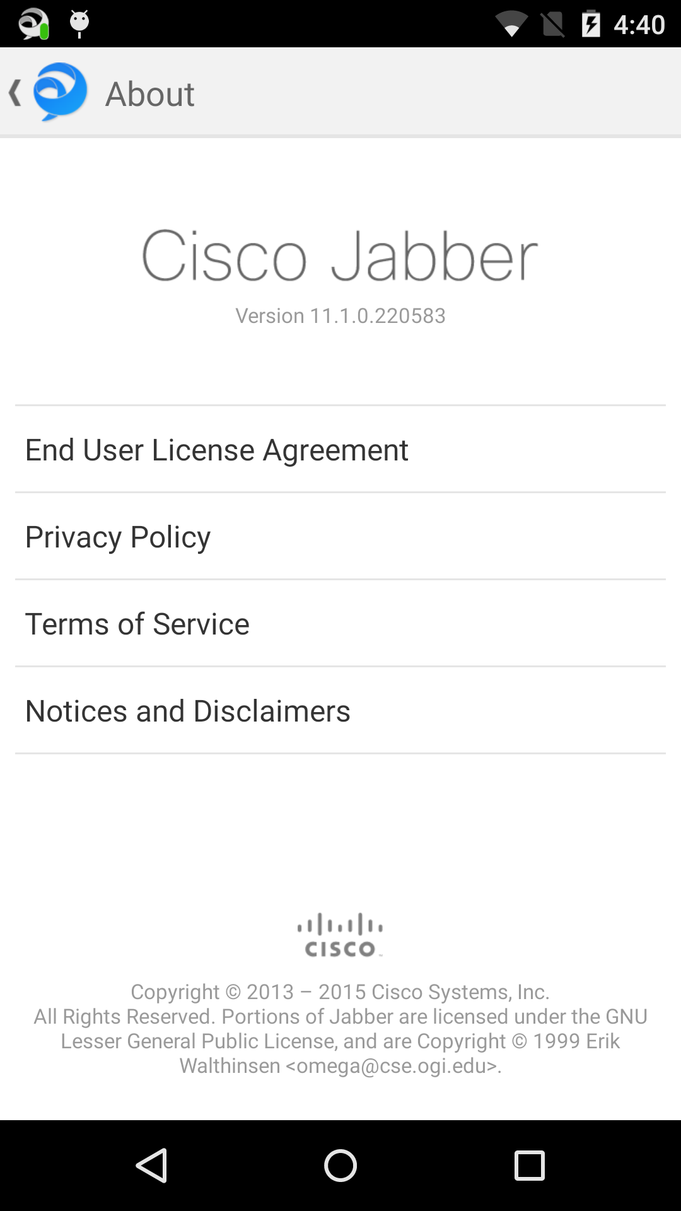
V 11.1.0.x on Google Nexus 9 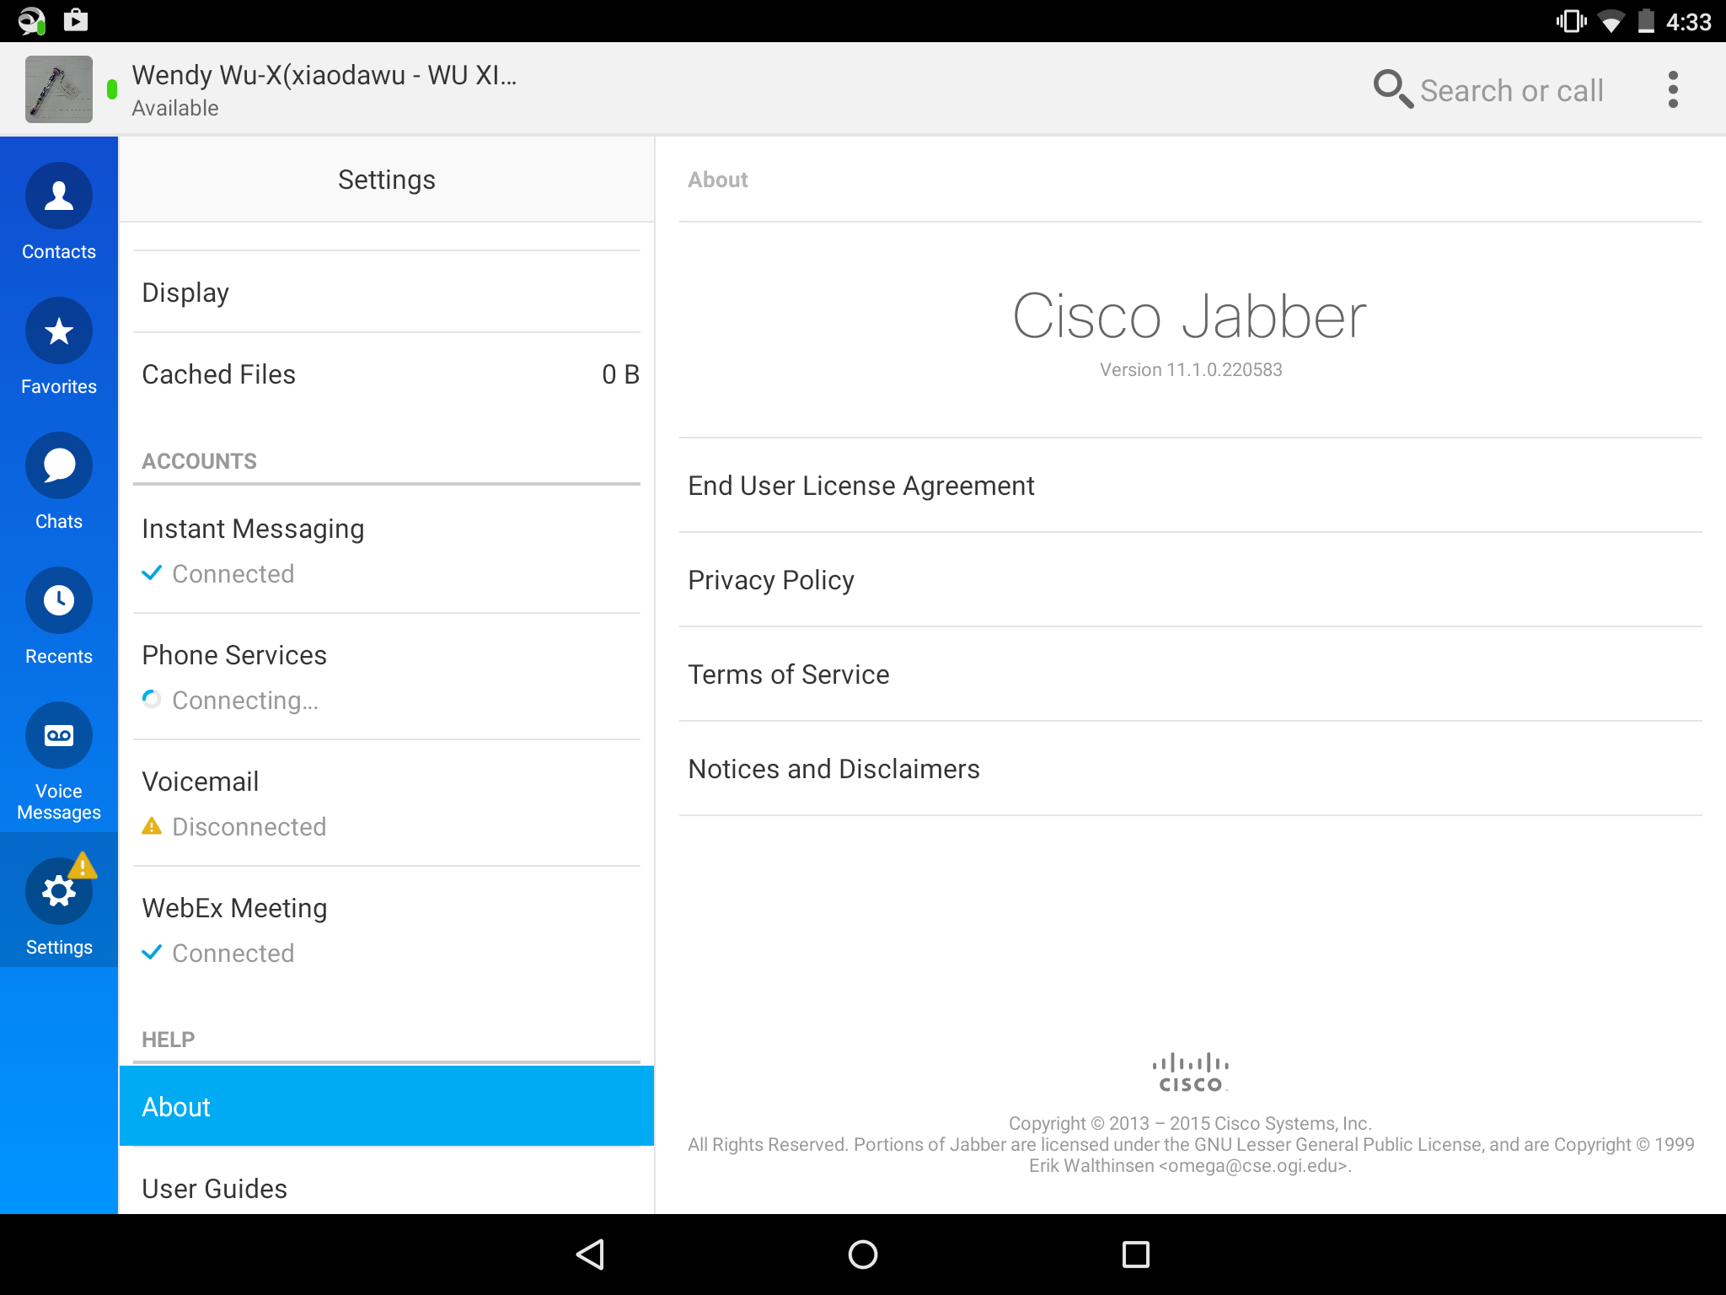

V11.1.0.x on Cisco DX 80
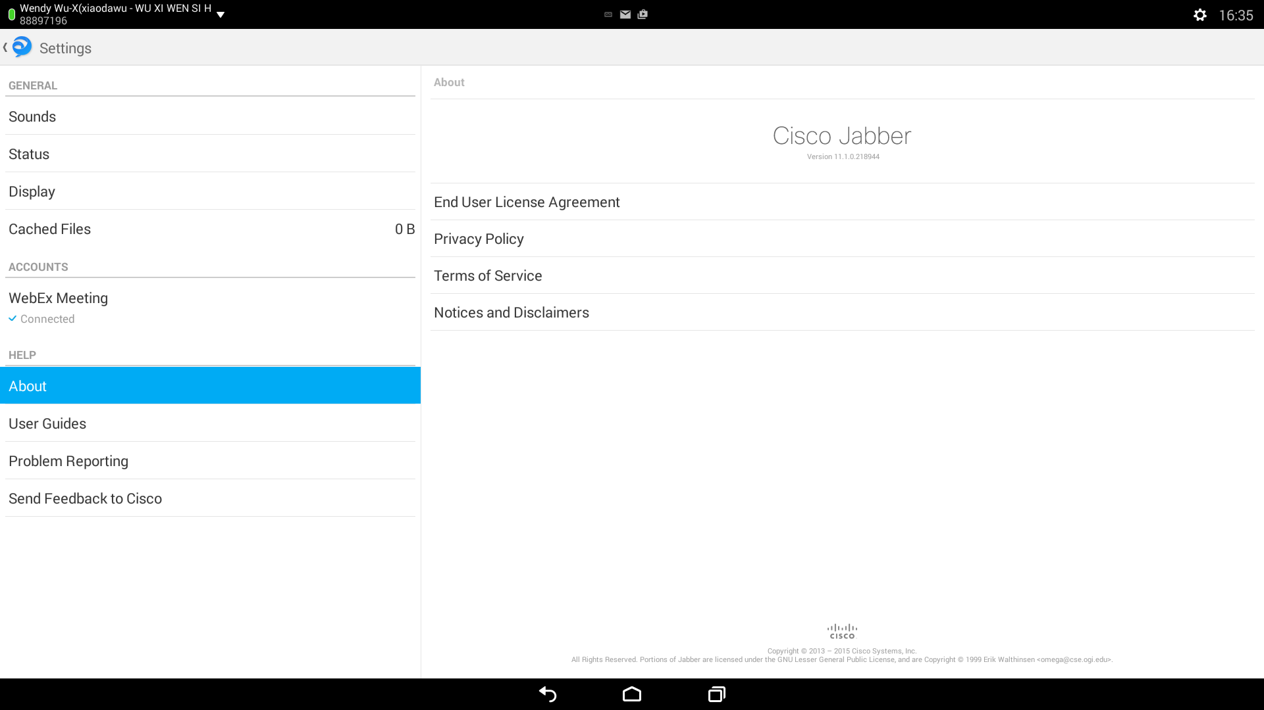

Section 1194.21: Software Applications and Operating Systems – Detail
508 Clause | Criteria | Supporting Features | Remarks and Explanations
1194.21(a) | When software is designed to run on a system that has a keyboard, product functions shall be executable from a keyboard where the function itself or the result of performing a function can be discerned textually. | Supports | OS provides on-screen keyboard. User can also use Explore-by-touch.
1194.21(b) | Applications shall not disrupt or disable activated features of other products that are identified as accessibility features, where those features are developed and documented according to industry standards. Applications also shall not disrupt or disable activated features of any operating system that are identified as accessibility features where the application programming interface for those accessibility features has been documented by the manufacturer of the operating system and is available to the product developer. | Supports
1194.21(c) | A well-defined on-screen indication of the current focus shall be provided that moves among interactive interface elements as the input focus changes. The focus shall be programmatically exposed so that Assistive Technology can track focus and focus changes. | Supports with Exception | The emoticon panel in the chat screen has no focus on the Tablet.
1194.21(d) | Sufficient information about a user interface element including the identity, operation and state of the element shall be available to Assistive Technology. When an image represents a program element, the information conveyed by the image must also be available in text. | Supports
1194.21(e) | When bitmap images are used to identify controls, status indicators, or other programmatic elements, the meaning assigned to those images shall be consistent throughout an application's performance. | Supports
1194.21(f) | Textual information shall be provided through operating system functions for displaying text. The minimum information that shall be made available is text content, text input caret location, and text attributes. | Supports
1194.21(g) | Applications shall not override user selected contrast and color selections and other individual display attributes. | Supports | Invert colors available on some devices
1194.21(h) | When animation is displayed, the information shall be displayable in at least one non-animated presentation mode at the option of the user. | Supports
1194.21(i) | Color coding shall not be used as the only means of conveying information, indicating an action, prompting a response, or distinguishing a visual element. | Supports | Icons can be selected to replace user status colors
1194.21(j) | When a product permits a user to adjust color and contrast settings, a variety of color selections capable of producing a range of contrast levels shall be provided. | Not applicable | No such adjustments available
1194.21(k) | Software shall not use flashing or blinking text, objects, or other elements having a flash or blink frequency greater than 2 Hz and lower than 55 Hz. | Supports | No flashing elements
1194.21(l) | When electronic forms are used, the form shall allow people using Assistive Technology to access the information, field elements, and functionality required for completion and submission of the form, including all directions and cues. | Supports | OS provides Talkback screen-reader and on-screen keyboard

Section 1194.31: Functional Performance Criteria – Detail
508 Clause | Criteria | Supporting Features | Remarks and Explanations
1194.31(a) | At least one mode of operation and information retrieval that does not require user vision shall be provided, or support for Assistive Technology used by people who are blind or visually impaired shall be provided. | Supports with Exception | OS provides Talkback, screen reader and visible focus changes. But still need to provide more meaningful text to some UI elements. And the way to answer/decline an incoming call is not friendly enough.
1194.31(b) | At least one mode of operation and information retrieval that does not require visual acuity greater than 20/70 shall be provided in audio and enlarged print output working together or independently, or support for Assistive Technology used by people who are visually impaired shall be provided. | Supports | OS provides Talkback, screen reader and visible focus changes, text size is adjustable, and Zoom feature
1194.31(c) | At least one mode of operation and information retrieval that does not require user hearing shall be provided, or support for Assistive Technology used by people who are deaf or hard of hearing shall be provided | Supports
1194.31(d) | Where audio information is important for the use of a product, at least one mode of operation and information retrieval shall be provided in an enhanced auditory fashion, or support for assistive hearing devices shall be provided. | Supports
1194.31(e) | At least one mode of operation and information retrieval that does not require user speech shall be provided, or support for Assistive Technology used by people with disabilities shall be provided. | Supports
1194.31(f) | At least one mode of operation and information retrieval that does not require fine motor control or simultaneous actions and that is operable with limited reach and strength shall be provided. | Supports

Section 1194.41: Information, Documentation and Support - Detail
508 Clause | Criteria | Supporting Features | Remarks and Explanations
1194.41(a) | Product support documentation provided to end-users shall be made available in alternate formats upon request, at no additional charge | Supports | Accessible documentation is available through Cisco TAC upon request.
1194.41(b) | End-users shall have access to a description of the accessibility and compatibility features of products in alternate formats or alternate methods upon request, at no additional charge. | Supports | Accessible documentation is available through Cisco TAC upon request.
1194.41(c) | Support services for products shall accommodate the communication needs of end-users with disabilities. | Supports | Cisco conforms through equal facilitation. Customers may reach Cisco Technical Assistance Center (TAC) via Phone, Email or Web Form. All cases open through email or web are opened as Priority 3 cases. All Priority 1 or Priority 2 case can only be opened via the telephone. TTY users must call the Text Relay Service (TRS) by dialing 711 or their state Video Relay Service (VRS) and have the TRS agent contact Cisco TAC via voice.

Supporting Feature (Status) Terminology
The result of “Accessibility Testing" assists in the determination of the Supporting Features.

Supporting Features or Status
Supports | Use this language when you determine the product fully meets the letter and intent of the Criteria.
Supports with Exceptions | Use this language when you determine the product does not fully meet the letter and intent of the Criteria, but provides some level of access relative to the Criteria. Please document the exception in the “Remarks and Explanations” column.
Supports through Equivalent Facilitation | Use this language when you have identified an alternate way to meet the intent of the Criteria or when the product does not fully meet the intent of the Criteria. Please document the exception in the “Remarks and Explanations” column.
Supports when combined with Compatible Assistive Technology | Use this language when you determine the product fully meets the letter and intent of the Criteria when used in combination with Compatible Assistive Technology. For example, many software programs can provide speech output when combined with a compatible screen reader (commonly used assistive technology for people who are blind). Please document the exception in the “Remarks and Explanations” column.
Does not Support | Use this language when you determine the product does not meet the letter or intent of the Criteria. Please document the reason in the “Remarks and Explanations” column.
Not Applicable | Use this language when you determine that the Criteria do not apply to the specific product. For example, many web applications don't have video content the "Not Applicable" can be used. Please state "The application does not have any video content" in the “Remarks and Explanations” column. Please document the reason in the “Remarks and Explanations” column.

