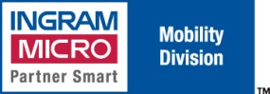**Ingram Micro – Cisco/AT&T Program** [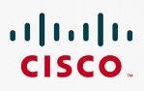](http://images.google.com/imgres?imgurl=http://www.skymetercorp.com/cms/images/stories/Logos/CiscoSystems.gif&imgrefurl=http://www.skymetercorp.com/cms/index.php?option=com_content&task=view&id=110&Itemid=139&usg=__t0nmf-SqMf9a64cxs5qLqZZMqEo=&h=617&w=975&sz=13&hl=en&start=1&itbs=1&tbnid=8unU5vUawesT_M:&tbnh=94&tbnw=149&prev=/images?q=cisco&gbv=2&hl=en)

**Activation of Cisco Devices on AT&T**

Cisco is partnering with Ingram Micro Mobility in an awareness campaign designed to increase AT&T activations of the Cisco embedded products. The program will offer resellers of the AT&T embedded Cisco Modems a commission when sold with an accompanying activation of the device. The activations will be performed by Ingram Micro’s Mobility team or by the resellers themselves.

**Program Highlights:**

* $13 - $173 Activation Credit will be applied to the Reseller’s Ingram Micro account when purchased with activation on AT&T.
* AT&T activation must be processed by Ingram Micro Mobility Team.
* Hardware can be sourced through any authorized distributor.

**Cisco AT&T Embedded SKUs**

* **BA6661** – CISCO881G-A-K9
* **V07984 –** CISCO881GW-GN-A-K9 with mandatory PCEX-3G-HSPA-A

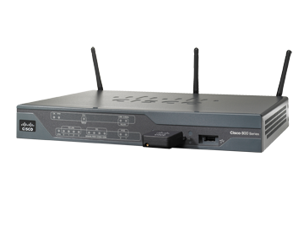

***Cisco Activation Program Compensation***

**Standard Commission**

|  |  |
| --- | --- |
| **MRC Tier** | **Reseller Commission \*** |
| **$8.98 - $11.98** | **$13.00** |
| **$11.99 - $19.98** | **$22.00** |
| **$19.99 - $29.98** | **$31.00** |
| **$29.99 - $39.98** | **$47.00** |
| **$39.99 - $49.98** | **$63.00** |
| **$49.99 - $59.98** | **$75.00** |
| **$59.99 - $79.98** | **$110.00** |
| **$79.99 - $99.98** | **$126.00** |
| **$99.99 +** | **$173.00** |

**Contact –**

**Brad Banas David Hemmer**

**Office: (800) 456-8000 x66011 Office: (800) 456-8000 x66678** [brad.banas@ingrammicro.com](mailto:brad.banas@ingrammicro.com)[david.hemmer@ingrammicro.com](mailto:david.hemmer@ingrammicro.com)