Cisco EnergyWise is an energy management protocol based on Cisco IOS® Software for monitoring, controlling, and reporting the energy use of information technology (IT) and facilities equipment. It helps manage the energy consumption of a wide array of IT devices connected to the network and is available and configurable across the current Cisco Catalyst® switching and Cisco Integrated Services Router Generation 2 (ISR G2) routing portfolio. Cisco EnergyWise is also supported through a broad range of Power over Ethernet (PoE) end-devices such as IP phones, wireless access points, security cameras, door access systems, and virtual desktop thin and zero client infrastructures. Cisco EnergyWise ecosystem partners also offer a wide range of Cisco approved IP-enabled devices and sub meters.

Cisco EnergyWise enables visibility and control for power optimization of the network infrastructure and network-attached devices and yields sustainability, environmental benefits, operational excellence, and reduced costs.

Cisco EnergyWise represents a highly intelligent network-based approach for energy measurement and control messages between management applications and endpoints. The network discovers Cisco EnergyWise manageable devices and enables the monitoring of power consumption using a unique domain-naming system to query and summarize information from large sets of devices. The result is a Network Based Energy Management system that provides a more comprehensive view of power consumption than traditional network management applications.

Following standard business guidelines, Cisco EnergyWise network wide policies can be developed to control device power management, eliminating the need for separate IT and building energy systems across different enterprise borders.

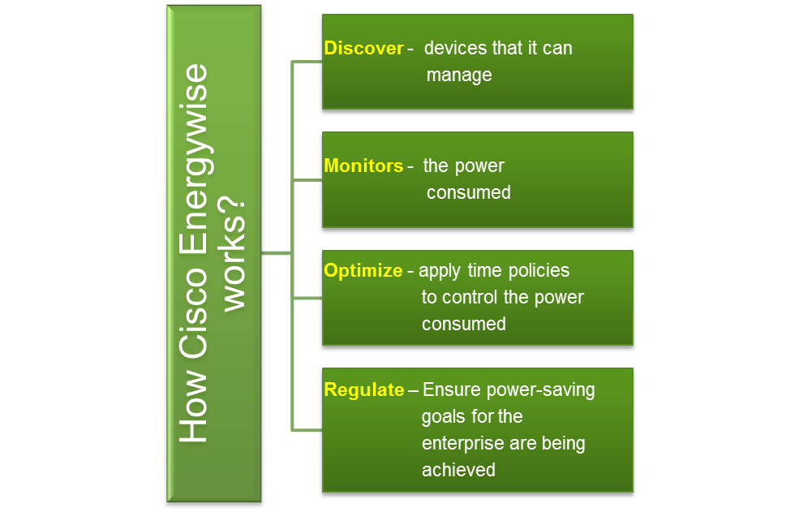

**Business Objective of IVT with Collabera**:

* Validate compliance of Cisco EnergyWise Partner’s implementation of EnergyWise SDK/API in a thorough and cost effective manner.

**Solution:**

•Engage Collabera India’s IVT resources to enable Cisco partners to get their products (application software and/or hardware) certified for interoperability with Cisco technologies.

**Business Value:**

* IVT certified products provide end customers the assurance that it has been pre-tested, reducing integration costs, accelerating deployments and minimizing risk of failure.

**Collabera IVT Test Lab:**

The intent of the IVT testing is to measure the correctness of the functionality of the CISCO ENERGY WISE SDK that is deployed on the Partners devices.

Collabera performs Interoperability Verification Testing (IVT) for Cisco's partners who want to promote their products and technologies as "Cisco EnergyWise Program Compatible." Collabera's IVT service is designed to enable Cisco partners to get their products (application software and/or hardware) certified for interoperability with Cisco technologies. IVT certified products provide end customers the assurance that it has been pre-tested, reducing integration costs, accelerating deployments and minimizing risk of failure.

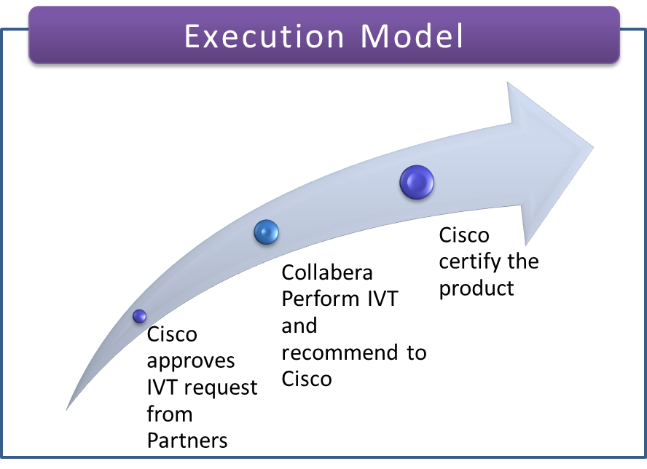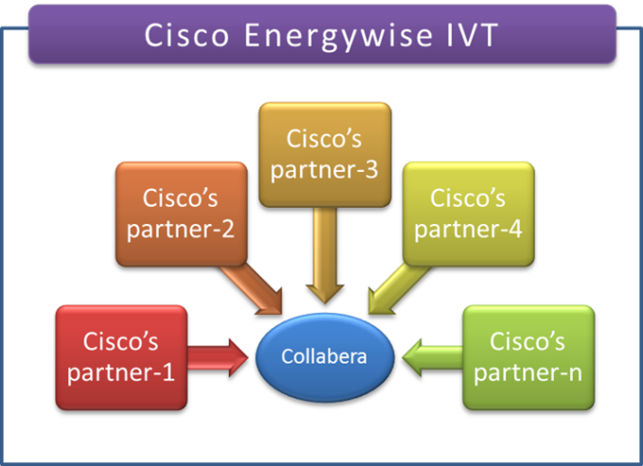

**Collabera:**

Collabera is a fast growing, end-to-end information technology services and solutions provider working with leading Global 2000 organizations from the Financial Services, Communications, Media, Manufacturing, Retail, Energy and Utilities domains.

Collabera employs over 6500 professionals across more than 20 offices and 3 world-class delivery centers in the USA, Europe and India. We deliver a full portfolio of services that include IT consulting, Application Development and Management, Independent Testing, Infrastructure Management Services, Enterprise Software Solutions, Business Intelligence & Data Warehousing Services and **Embedded & Wireless Services**.

Our **Embedded & Wireless** group provides design and support services for the entire product life cycle. This includes **Product Feasibility Analysis, Development, Test Development, Test Automation, Product Testing, Software QA, Maintenance and Sustenance Engineering**.

**Software Development activities include: BSP** development for various x86 & ARM processor based platforms, Device Driver Development, Porting / Customization of OS and Application Development on Windows Mobile, WinCE, WEH, Linux, Android etc.,

 The diagram below illustrates our Embedded & Wireless capabilities.

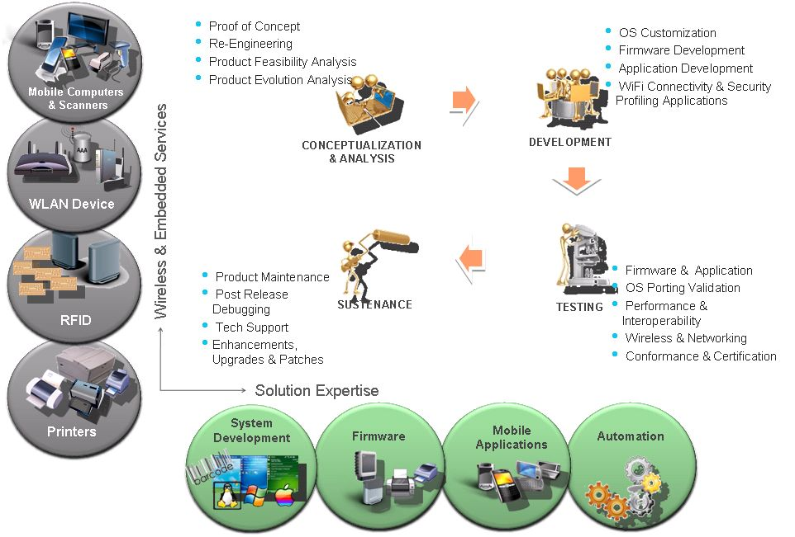

For more Information visit <http://collabera.com/services/wireless_embedded.jsp> or send email to [solutions@collabera.com](mailto:solutions@collabera.com)